|  |
| --- |
| e-PG Pathshala logo.png  **Information Technology** |
| **Mobile Computing**  **Module: Spread Spectrum Technology: Direct Sequence Spread Spectrum** |
|  |

## **Learning Objectives**

* Understand the principle of Direct Sequence Spread Spectrum
* Understand the concept of spreading codes and study their properties
* Discuss orthogonal codes
* By illustration understand how data is transmitted using codes and how it is recovered back at receiving station

## **Introduction**

In Direct Sequence spread spectrum, Each bit in the original signal is represented by multiple bits in transmitted signal with the help of a code known as spreading code. The code appears to be pseudo random in nature while actually it is deterministic. The P-R code is also called pseudo codes. The signal is spreaded in proportion with the number of bits in the code. For example 11-bit code spreads the signal 11 times greater than 1 bit code. The code is independent of data to be transmitted. This is intercepted by only those receivers who know the code, for rest it is rejected as noise. Therefore the code is also known as pseudo-random noise.

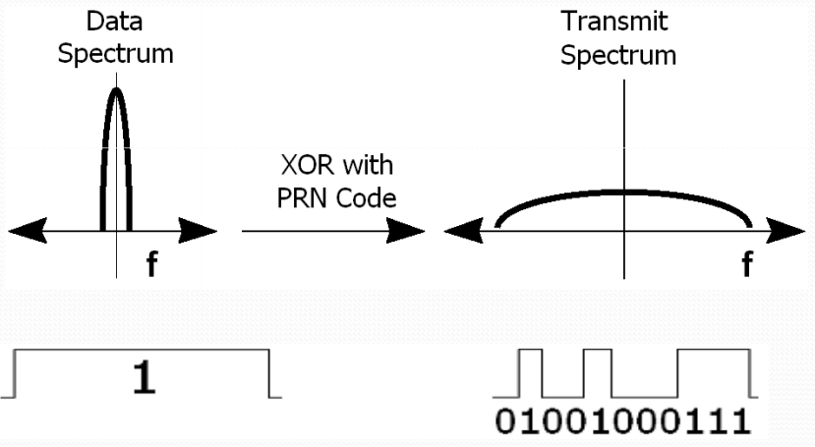

Figure 1: Spreading of bandwidth

## **The magical codes**

Let us understand the concept of codes via the given example.

Let us assume that there are two users. They transmit two symbols d1 and d2. A symbol is a bit obtained after encoding and decoding of noise and data. User 1 transmits symbol d1 and user 2 transmits symbol d2. The two users are assigned distinct codes as:

1,0,1,0

1010

0101

CHORUS

**User 1: <1, 1, 1, 1>=1+1+-1+-1=0**

**User 2: <1, -1, -1, -1>**

To transmit the symbol with the code, the symbol is multiplied with the code. Therefore symbol of user 1 is transmitted as

**<d1, d1, d1, d1>**

and of user2 is transmitted as

**<d2, d2, -d2, -d2>**

Therefore a single symbol is transmitted as a sequence of symbols.

These sub-symbols are known as chips and the sequence as known as chipping sequence.

Now the two users transmit simultaneously. Their signals will linearly add up. Therefore resultant signal is:

S = <d1, d1, d1, d1> + <d2, -d2, -d2, -d2>= <d1+d2, d1-d2, d1-d2, d1-d2>

At the receiving end, to recover the symbol of the user, it is multiplied with the code and correspondingly add the products. This technique is known as finding the correlation.

S. <1, 1, 1, 1> = <d1+d2, d1-d2, d1-d2, d1-d2>. <1, 1, 1, 1>= d1+d1+d1+d1 = 4d1

D1+D2+D1-D2+D1-D2+D1-D2=4D1-2D2

Signal of user 2 has disappeared!!!!

S. <1, 1, 1, 1> = <d1+d2, d1+d2, d1-d2, d1-d2>. <1, -1, -1, -1>= d2+d2+d2+d2 = 4d2

-2D1+4D2

Signal of user 1 has disappeared!!!!

***So we see that by finding the correlation of the resultant signal with the code of the user, we are able to retrieve its data.***

The interference from the other user is surprisingly nullified. This is the beauty of the codes.

What is the magic behind this? Would the same thing happen if I change the codes?

The answer is NO. Because these codes are unique. What is the uniqueness?

Just find dot product/correlation between these codes.

<1, 1, 1, 1> . <1, 1, -1, -1> = 1+1-1-1 = 0

It comes out to be 0. Such codes are called orthogonal codes.

Therefore using orthogonal codes, we have been able to able to send symbols of two users simultaneously on the same channel without interference. This is the basic technology used in CDMA, CDMAone, IS-95 and so on. The code appears to be random hence the name pseudo-random sequence. The receiver should know the code to retrieve the symbol. For those who do not know the code, it appears as noise hence the name pseudo-random noise.

## **Spreading of Bandwidth**

Let us see how the signal is spreaded. Before spreading, Suppose the bit rate is 1 kbps. To transmit a single bit, time required = $tb =\frac{1}{1kbps}=1ms$ $BW= \frac{1}{t_{b}}=1KHz$

After spreading to keep the bit rate constant, time required to send a chip or sub symbol is $\frac{1}{4}$ hence $t_{c}=\frac{1}{4}t_{b}$ $t_{c}=\frac{1}{4}ms$

Frequency $BW=\frac{1}{t_{c}}=4KHz$

We see that BW has spreaded by 4 times (Fig. 2)

1KHz

4KHz

1

Figure 2 Spreading of Bandwidth

Therefore the code is also known as “spreading code” .You can see in the Fig. 1 that bit 1 is transmitted as sequence of bits using the code “1011011100”

This code is known as Barker code & is used in IEEE 802.11.Now you have seen that now the chipping sequence or the PN sequence spreads the symbol by a factor of 11 which is also length of code. This is known as spreading factors

**Spreading factor = $\frac{t_{b}}{t_{c}}$**

Civil application use spreading factor between 10 and 100 military application use upto 10,000. Wireless LAN IEEE 802.11 uses sequence 10110111000 as barker code with spreading factor of 11.

We just saw in example that using 4 bit chipping sequence 2 users are able to transmit. Actually with 4 bit code, 4 orthogonal codes are possible. They are

<1, 1, 1, 1>

<1, -1, -1, 1> 4 pairs of orthogonal codes

<1, -1, 1, -1>

<1, 1, -1, -1>

There are N possible orthogonal codes of length N. Hence N users can access the medium simultaneously.

## **Principle of DSSS**

1. BW is spreaded with help of a code called spreading code. The code is independent of data
2. If m is length of code, the signal is spreaded by a factor of m
3. By using unique code, all users transmit using entire BW. During transmission, the signals of all users add up linearly instead of being garbled
4. The receiver receives sum of all signals. It is synchronizes with code of sender
5. To recover the data, the receiver correlates the received signal with user code

## **Illustration**

Let us see a signal is spreaded and transmitted

Let us suppose four stations have been assigned 4 bit code

**A: <1, 1, 1, 1> C: <1, -1, 1, -1>**

**B: <1, -1, -1, 1> D: <1, 1, -1, -1>**

This representation is a bipolar notation.

To transmit a 1 the code is transmitted as it and to transmit a 0, complement of the code is to be transmitted. At the receiver all the signals of all the stations add up linearly (Fig. 4)

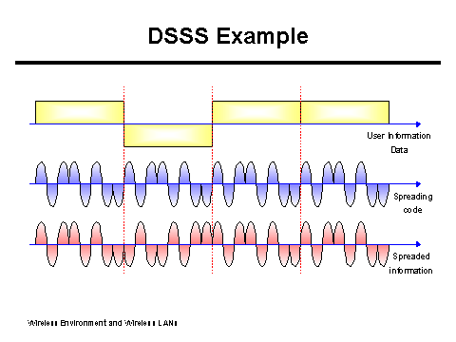

Figure 3: Sending of data by adding chipping sequence

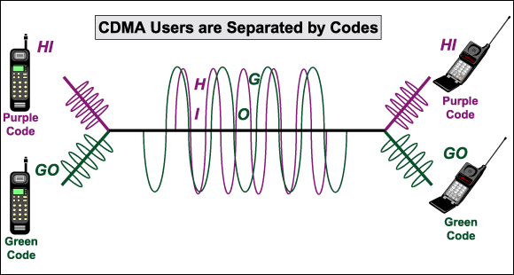

Figure 4: Signals add up linearly

Let us consider four cases

## **Case I: Only A transmits a 1**

**Resultant signal at sender**

S1 = <1, 1, 1, 1>.<1,1,1,1>=4/4=1

<1,1,1,1>.<1,-1,-1,1>=0

<1,1,1,1>.<1,-1,1,-1>=0

## **Case II: A transmits a 1 & B transmits 0**

A’s signal will be spreaded as <1, 1, 1, 1>, B’s signal as <-1, +1, +1, -1>

**Resultant signal at sender**

S2 = <0, +2, +2, 0>.<1,1,1,1> =4

<0,+2,+2,0>.<1,-1,-1,1>= -4

## **Case III: A transmits a 1 B transmits a 1 and C transmits a 0**

S3 = <1, 1, 1, 1>+ <1, -1, -1, 1>+ <-1, +1, -1, +1> = <1, 1, -1, 3>

Let us try to recover these signals at receiving side.

Let us recover the data stream of station **A**. For that find correlation of the received chip sequence with chip sequence or code of A. For that find inner product

## **Case I: S1 . A**

<1, 1, 1, 1> . <1, 1, 1, 1> = $\frac{4}{4}$ = 1

Inner product perform pairwise summary of chip sequence of A and received signal so the correct bit sent is recovered

## **Case II S2 . A**

<0, +2, +2, 0> <1, 1, 1, 1> = = 1

S2 . B

<0, +2, +2, 0> <1, -1, -1, 1> = $\frac{-4}{4}$ = -1

(-1) indicates B has transmitted a zero.

## **Case III**

S3 . A = <1, 1, -1, 3> <1, 1, 1, 1> = = 1

S3 . B = <1, 1, -1, 3> <1, -1,- 1, 1> = = 1

S3 . C = <1, 1, -1, 3> <1,- 1, 1,- 1> = $\frac{-4}{4}$ = -1

Now let us try to recover bit stream of a station when it has not transmitted at all. In all the three cases we can see that D has not transmitted. If we correlate the sequence of D with all three received signals, what do we get

S1 . D = <1, 1, -1, 3>. <1, 1,- 1,- 1> = 0

Similarly

S2 . D = <0, +2, +2, 0>. <1, 1,- 1,- 1> = 0

S3 . D = <1, 1, -1, 3>. <1, 1,- 1,- 1> = 0

This applies that in all 3 cases D did not transmit at all.

## **DSSS Sender**

Step 1: Spread the user data with the chipping sequence via digital modulation. Result is spreaded signal

Step 2: Spread signal is again modulated via a radio modulation

Step 3: This shifts the signal to carrier frequency

Step 4: Signal is transmitted

Spread spectrum signal

Transmit signal

User data

Modulator

Radio carrier

Chipping sequence

Figure 5: Block diagram of DSSS sender

## **DSSS Receiver**

1. Demodulate the received signal
2. Generate the same pseudo random sequence as the transmitter
3. Find the correlation with the pseudo random sequence by finding the product and integrating the products
4. Decision unit decides if this sum represent a binary 1 or 0

Correlation

Lowpass filtered signal

Data

Sampled sums

Products

Received signal

Decision

Integrator

X

Demodulator

Radio carrier

Chipping sequence

Figure 6: Block diagram of DSSS receiver

## **Rake receivers**

DSSS works well when transmitted and receiver and perfectly synchronized and the effect of noise or multipath propagation is not there. But in case of m path propagation there will be many paths of different delays between TX and RX. For this purpose rake receivers are used. They use n correlators for n paths. Each correlator is synchronized to the transmitter + delay of path. As soon as the receiver gets a new path which is stronger than current weak path, it assigns correlators to the new path. Output of all correlators will be combined to the decision unit.

## **Summary**

* Direct Sequence Spread Spectrum spreads the bandwidth by transmitting the data using PN code
* Only receivers who knows the code can intercept the data
* Codes are independent of data
* It provides built in security
* Bandwidth is spreaded by order of size of code
* Codes should be orthogonal
* At receiving end by finding correlation of signal with users code, data is retrieved back